***Introduction to explain VLAN Concepts and Configure VLANs on a Single Switch***

Configuration of VLANs

***How VLANs Change the world***

There is no security at all on a layer 2.

There is no Segmentation at layer 2.

There is no real way to differentiate devices at layer 2.

**WHAT VLANS SOLVE**

VLAN s create multiple broadcast domains/ subnets/ networks.

VLAN s extend the entire layer 2 fabric (stop at router).

VLAN s segment and isolate traffic.

TRUNKING – When you have multiple VLANs on a switch and you need to get the data across to another switch you don’t want to merge the VLANs together. By using a TRUNK (non cisco devices call it tagged) port, you add a header on the packet that says this packet belongs to this VLAN and you send the data over.

A switch will forward a broadcast message out each port within a domain. As a network grows and more traffic generates broadcasts, which of the following will help segment a network?

VLANs

***Routing Between VLANs***

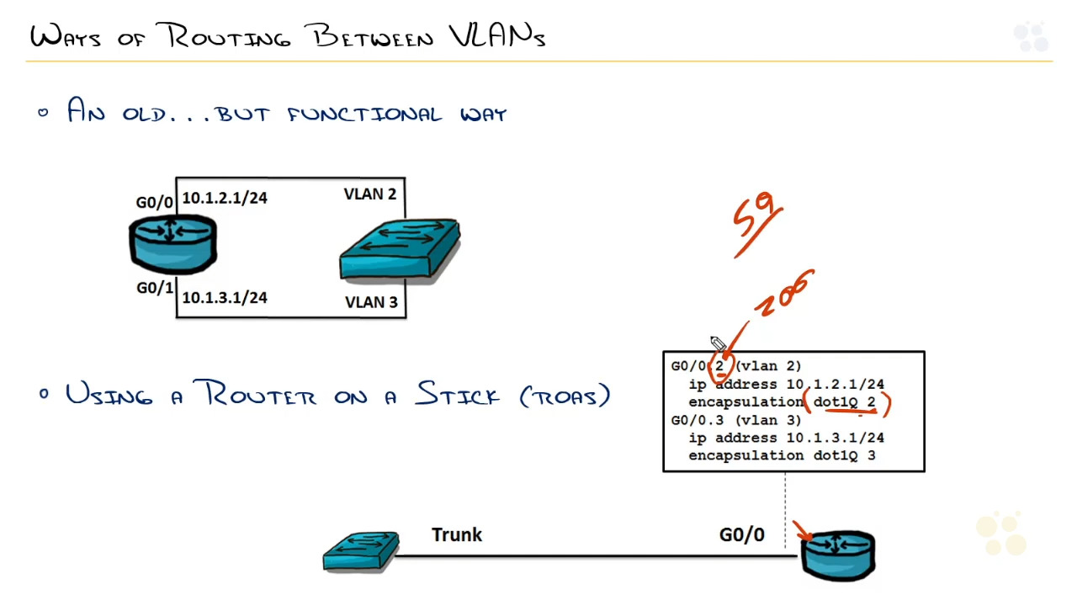

Using a layer 3 switch

When routing between VLANs you want to allow the 801.1q protocol so they can speak to each other. This can be done on a cisco layer 3 device by creating a sub-interface on that gigabit port allowing the trunked traffic (different vlans) to pass through. This way a single port can have a single server hosting various services, each running through its own vlan on a single port.

L3 switching takes the core of routing and makes it ASIC-Routing

Which of the following will allow routing between multiple VLANs?

A multilayer switch

Using a router interface per VLAN

Sub-interface with trunking

***Configuring CLANs on a Single Switch***

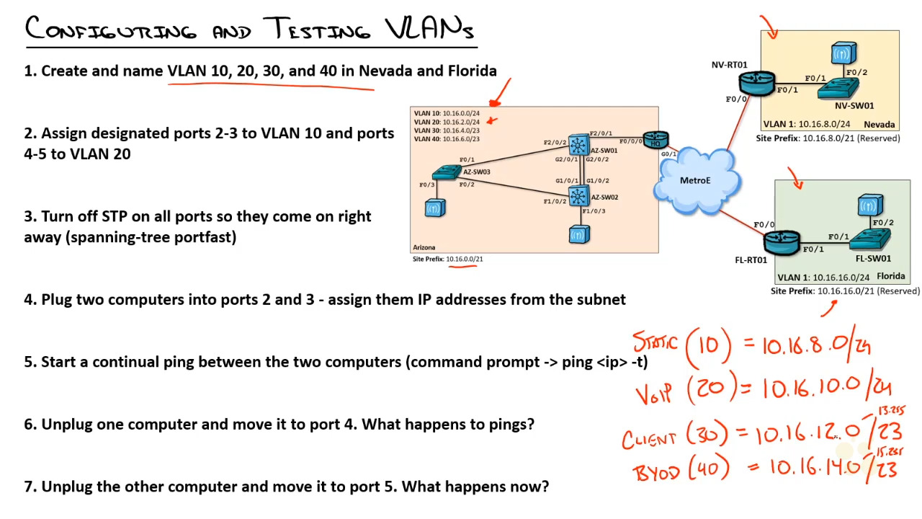

1. Create and name VLAN 10, 20, 30, and 40 in Nevada and Florida.
   1. Switch(config)#vlan 10
      1. Switch(config-vlan)#name STATIC
      2. Switch(config-vlan)#exit
   2. Switch(config)#vlan 20
      1. Switch(config-vlan)#name VOIP
      2. Switch(config-vlan)#exit
   3. Switch(config)#vlan 30
      1. Switch(config-vlan)#name client
      2. Switch(config-vlan)#exit
   4. Switch(config)#vlan 40
      1. Switch(config-vlan)#name BYOD
      2. Switch(config-vlan)#exit
2. Assign designated ports 2-3 to VLAN 10 and ports 4-5 to VLAN 20.
   1. Switch(config)#int fa0/2
      1. Switch(config-if)#switchport mode access
      2. Switch(config-if)#switchport access vlan 10
      3. Switch(config-if)#exit
   2. Switch(config)#int fa0/3
      1. Switch(config-if)#switchport mode access
      2. Switch(config-if)#switchport access vlan 10
      3. Switch(config-if)#exit
   3. Switch(config)#int fa0/4
      1. Switch(config-if)#switchport mode access
      2. Switch(config-if)#switchport access vlan 20
      3. Switch(config-if)#exit
   4. Switch(config)#int fa0/5
      1. Switch(config-if)#switchport mode access
      2. Switch(config-if)#switchport access vlan 20
      3. Switch(config-if)#exit

1. Turn off STP on all ports so they come on right away (spanning-tree portfast)
   1. Switch(config)#int range fa0/1-24
      1. Switch(config-if-range)#spanning-tree portfast
         1. %Warning: portfast should only be enabled on ports connected to a single host. Connecting hubs, concentrators, switches, bridges, etc... to this interface when portfast is enabled, can cause temporary bridging loops. Use with CAUTION
2. Plug two computers into ports 2 and 3 – assign them IP addresses from the subnet.
   1. 10.16.8.51
   2. 10.16.8.50
3. Start continual ping between the two computers(command prompt -> ping <ip> -t)
   1. Ping 10.16.8.50 -t
4. Unplug one computer and move it to port 4. What happens to pings?
   1. The ping stops because they are no longer on the same VLAN
5. Unplug the other computer and move it to port 5. What happens now?
   1. It picks back up again because they are now on the same vlan again.

Which of the following commands will assign access port F0/1 to VLAN 10?

Switchport access vlan 10

***Configuring a Router on a Stick***

Switch(config)#int fa0/1.1

Switch(config-if)#encapsulation dot1Q 10

Switch(config-if)#ip address 10.16.8.1 255.255.255.0

When configuring a router on a stick, which of the following is needed before you can set the IP address on the sub-interface?

Command: “encapsulation dot1Q 10”

***Configuring VLANs on a single Switch Lab***

1. Document the current IP address and gateway of PC-10
   1. IP address: 10.16.0.10
   2. Subnet mask: 255.255.255.0
   3. Default gateway:10.16.0.1
2. Assign PC-10 the Ip address 10.16.2.20/24 (no gateway)
3. View the current VLAN configuration on Access1. Based on the current configuration, should PC-10 be able to ping PC-20? Test your theory.
   1. Same Vlan same subnet so yes the communication goes through
4. Create Vlan 10 and Vlan 20 on the Access 1 switch.
   1. Access1 (config)#vlan 10
      1. Access1 (config-vlan)#name VOIP
   2. Access1 (config)#vlan 20
      1. Access1 (config-vlan)#name client
   3. Access1 (config)#do show vlan
5. Assign both PC-10 and PC-20 switch ports to VLAN 20. Based on this new configuration, should PC-10 be able to ping PC-20? Test your theory.
   1. Access1 (config)#int g0/0
      1. Access1 (config)#switchport access vlan 20
   2. Access1 (config)#int g0/1
      1. Access1 (config)#switchport access vlan 20

Based on this new configuration both PC are on the same VLAN. With the same Vlan and the same subnet they should be able to communicate with each other.

1. Now, configure the PC-10 switch port in VLAN 10. Based on this new configuration, should PC-10 be able to ping PC-20? Test your theory.
   1. Access1 (config)#int g0/0
      1. Access1 (config)#switchport access vlan 10

Since both PC are on a different VLAN, they are not able to communicate with each other, even though they have the same subnet.

To create network VLANs, which configuration mode should you use?

Global

***Review of explain VLAN Concepts and Configure VLANs on a Single Switch***